Overdale Community Primary School – EYFS Autumn Term 1.2 2023
Theme: Let’s Celebrate
Specific Area: Literacy  Focus Texts – Let Me Come In/How to Keep Warm  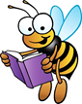  We will be learning to oral blend and segment  We will practise writing CVC/CVCC words and tricky words using  Phase 2 phonics  We will practise letter formation and writing our names  We will be using Talk For Writing to develop our story telling and  to create our own stories  We will be ordering events, labelling characters, writing based on our topical focus and writing letters  We will learn new vocabulary with Word Aware  We will learn poems with The Poetry Basket  We will share a variety of topical books, non-fiction books, alongside reading for pleasure. |  | 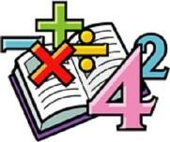  Specific Area: Mathematics  White Rose Maths – circles and triangles, 1, 2, 3, 4 and 5, shapes with 4 sides, consolidation  We will identify and name circles and triangles before making comparisons between the shapes  We will identify and explore shapes in the environment  We will be using positional language to explain where things are or how to get somewhere, using vocabulary such as in, under, between, beside, behind  We will introduce, find, subitise and represent numbers 4 and 5  We will form these numbers and explore how they are composed  We will find 1 more and 1 less and look at how we can add/takeaway to make different amounts  We will then revisit the composition of numbers 1 to 5 and begin to think about number bonds  We will identify, name and combine shapes with 4 sides  We will be sequencing events and looking at day and night, including time  We will then consolidate previous learning such as sorting, comparing and patterns
Specific Area: Knowledge and Understanding of the World  We will be practising using an iPad to take photographs, to open QR codes to read books and access educational apps, as well as to develop ideas  We will be learning about different celebrations around the world, including  Bonfire Night, Children in Need, Diwali, Thanksgiving, Hannukah, Advent and Christmas. We will identify on our classroom map the countries we visit during this learning.  We will be looking at how people prepare for celebrations and the similarities and differences between those that we celebrate.  We will be immersing ourselves in all things ‘Autumn’, including learning about hibernation, how to keep warm and changes in time.  We will be discussing times that are special to us and why. | Celebrations  BIG QUESTION  How do people around the world celebrate different occasions? |  | Specific Area: Personal and Social Development (PSED)  We will be learning about respecting ourselves, others and our environment  We will think about building relationships, sharing and our uniqueness  We will celebrate our similarities and differences  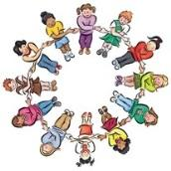  We will continue to identify our feelings and use the Colour Monster as a way to support children in recognising and coping with different emotions  We will continue to widen our experiences and focus on developing confidence to try new things  We will continue to discuss healthy habits: having a balanced diet, healthy teeth, looking after our bodies.
Specific Area: Physical Development  This half term we will continue to focus on getting changed independently, for example taking on and off jumpers/shoes and putting on coats  In PE we will be developing our fine motor skills, including threading, building and using the strength in our hands to manipulate objects  We will learn about how we can look after our bodies, including appropriate clothing as the seasons changes. We will continue to discuss healthy feelings and habits.  In literacy we will be practising our handwriting and making sure  that we get the size and shape of the letters correct  We will be developing our fine motor skills through activities  such as pen disco, dough disco alongside developing scissor skills | Prime Area: Communication and  Language  We will be focusing on our speaking and listening skills – taking turns to speak and listening to each other during small group sessions and whole class circle times  We will be focusing on our oral blending skills and listening to sounds in words in order to identify them  We will be using our Word Aware  scheme to learn new vocabulary with  Concept Cat  We will be focusing on offering our own ideas and using newly introduced vocabulary  We will communicate our own stories in Talk for Writing and practise performing in these sessions |  | Specific Area: Expressive Arts and Design Music  We will be exploring colour mixing to create firework pictures and will develop our joining techniques to create rockets  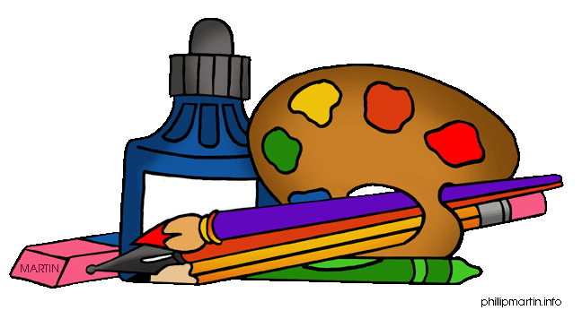  We will begin to think about design processes before making things  We will use clay to make Diya lamps  We will make scarecrow masks to celebrate Thanksgiving  We will be creating character props to support Talk for Writing learning  We will be learning simple rhymes and songs linked to our theme  We will be learning Nativity songs and practising our performance  We will have access to our classroom home corner that will be enhanced throughout the half term

